Robot Framework
Handbook
Table of Contents
1 What is Test Automation Framework? 3
2 Test Automation Framework Architecture 3
3 Folder Structure 4
4 Starting the Execution 7
4.1 Using RIDE 7
4.2 Using one-click Batch file 8
5 Change History 8

What is Test Automation Framework?

An Automation Framework is a set of guidelines that you can follow during test case scripting to achieve the desired results. This set of guidelines can be anything such as –

- Specifying the folder structure that will be used for storing test cases, function libraries, object repositories and data sheets.
- Deciding the format of the data sheets i.e., how the data sheets would be grouped and how the scripts will access these data sheets.
- Following proper coding standards and using comments so that the code can be understood easily by anyone.
- Using reusable functions wherever possible so that lesser amount of rework is needed in case of any changes

Test Automation Framework Architecture

3 Folder Structure
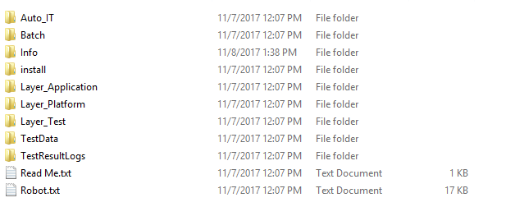
The Robot Framework consists of above folders:

- Auto_IT
- Batch
- Info
- Install
- Layer_Application
- Layer_platform
- Layer_Test
- TestData
- TestResultLogs
Auto IT – Contains libraries for windows applications.
Batch - Consists of batch files essential for RF.
Info - Consists all the informative files such as Robot Framework Functions, Pip Installation Commands, and GIT Commands etc.
Install - Consists of some useful drivers required for RF.
Layer_Application – Consists of two folders Common functions and OR (Object Repository). This Object repository contains the collection of objects and will be shared across multiple test cases of an application.

Layer_Platform – Consists of libraries required for framework. In framework libraries we can store the functions for more than one application in the project. We can say that these are the functions they actually interact with the application. Libraries also use some of the functions from Utilities.
The application specific library contains the function which is specific to the application and can be reused multiple times for the same application.
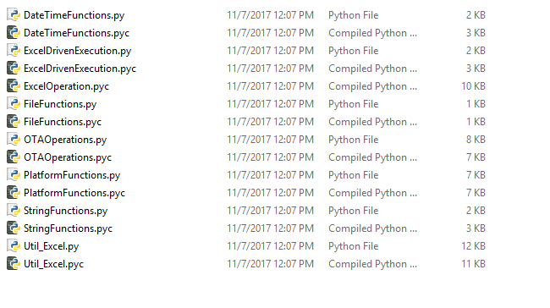
Layer_Test – Consists of TestConfig folder, which includes Application Modules excel. This excel consists of list of all the modules which are to be executed. This entity enables the user to execute the selected set of test cases. This is the excel document which contains the test cases to run automatically. This entity can also be a database i.e. MySQL, MSSQL in order to manage the test cases to be executed through the Automation Framework.
From the module, user can select the test cases to be executed and then those will be the candidates for automated execution. This Component is not the part of testing tool.
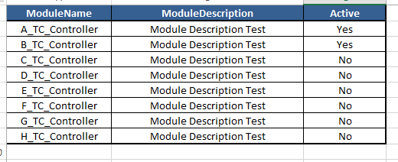
Each module will have an independent excel sheet in which the data related to that particular module will be stored like how many test cases and which test case is to be executed by selecting Yes or No.

TestData- Test data required for all the test cases in the Project is stored here .
Since the data is collected in the dictionary object, the underlying data structure used of storing the data (currently excel sheet) can be changed at any time without affecting the code.
This test data is coupled with the test case using a unique Test ID. In basic framework the test data is stored in excel files but if needed a database (MySQL, MSSQL) can also be used for enhanced security of the test data.
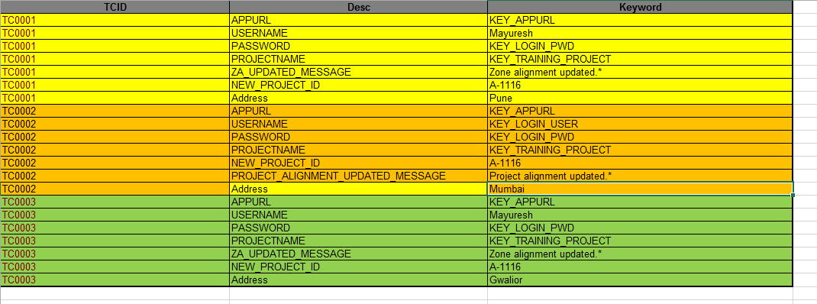

TestResultLogs –
Consists of two temp folders and other result folders. This folder exists in every application tree and contains the logs for each execution for the application. Currently with every execution a new folder will be created named as per the timestamp and this will contains the Robot framework execution result.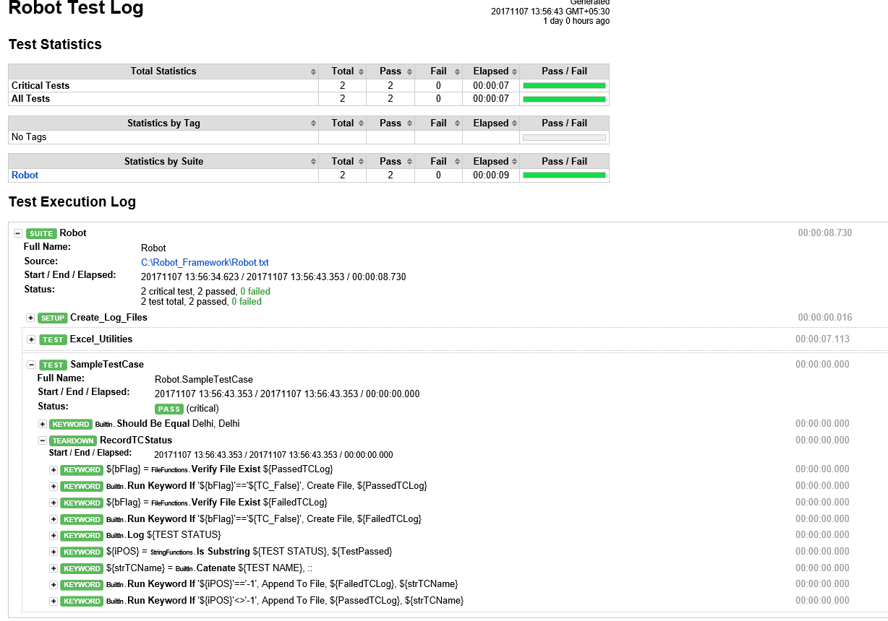

Starting the Execution
Once all the pre-requisites are set, the execution can be started. There are two ways the user can start the execution of the suite:
- Using Ride
- Using one-click Batch file

Using RIDE
To execute scripts from RIDE, launch RIDE from Run>>type “ride.py” as shown in the screenshot below:
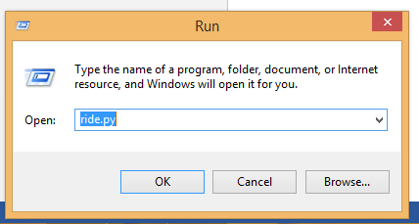

Once RIDE is open, check if the script is stored on local drive and follow the below given steps accordingly.
Once the script is open, select the required test cases and click on the Run button. On the next window, click on the Start button to start the execution.

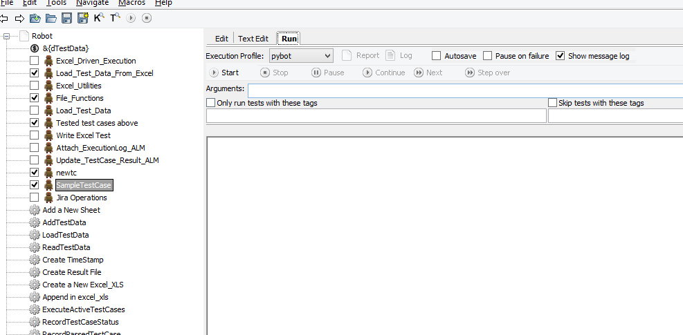

Execution of the script will start as shown below.

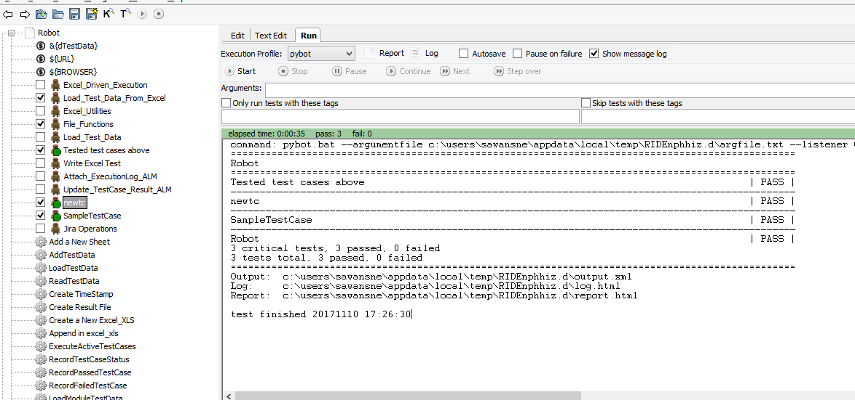

4.2 Using one-click Batch file

Batch files can be created which will contain the command line execution steps for the selected test cases. The scoping of test cases can be done on execution controller excel. For detailed steps please follow section 2>>Layer Test.

These batch files (*.bat) will be helpful while triggering the Robot scripts from any CI/CD tools like Jenkins, Bamboo or TeamCity.

5 Change History

Version | Date | Author | Reviewed by | Approved by | Change history
Version 1.0 | 2014-18-11 | Snehal Sawant |  |  | Created the document -- Draft Version

